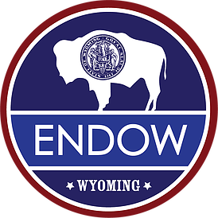
ENDOW Executive Council Meeting Minutes
Casper – October 2017

Executive Summary
- Provide feedback to Jerimiah regarding the proposed legislative recommendations and ANY OTHER legislative action you would like to see presented by November 5th
- Meeting take-aways include more specific model for ENDOW discussions, consensus on engaging business and community leaders in a different way, where leaders drive and guide. Government responds, rather than “sells.”
- Articulated consensus that these efforts are critical for planting trees that will provide shade for future generations. “This is a marathon, not a sprint.”
- Draft review for the December Report will be ready November 6th
- Next Meeting: December 11 and 12, Laramie, WY

Status Updates
- Advisory Council Update
  - Suggest focusing on healthcare, minerals and energy, tourism, finance, manufacturing, technology, agriculture (especially value-added). Ready and willing to help with action plan. Planning next meeting for March, TBD.

- Subcommittee Reports (see Appendix, Potential Recommendations v1)
  - Public Policy - Entrepreneurship
Produced a whitepaper on entrepreneurial ecosystem
  - Infrastructure
Internet accessibility
Support the Aeronautics Task Force legislative recommendations (capacity purchase agreement – combining air service funding support instead of community by community)

  - Workforce Development
Community colleges, UW, trade schools ready to help but need direction in terms of what economic sectors to train for. Want to involve K-12 Leaders

  - Quality of Life
Committee came to consensus that they’d be more effective rolling their work into other committees

A Model for Developing a Diversified Economy via ENDOW
Wyoming’s House: a proposed model for diversified economy (see diagram below)
Diversified economy of 2038 has a multi-layer foundation: Workforce, Infrastructure, Quality of Life, and Leadership/Public Policy. Pillars represent new and emerging industry sectors. Sectors depend on a solid foundation. Circles of influence represent various communities and groups that provide information and resources to strengthen fortify and solidify the foundation.
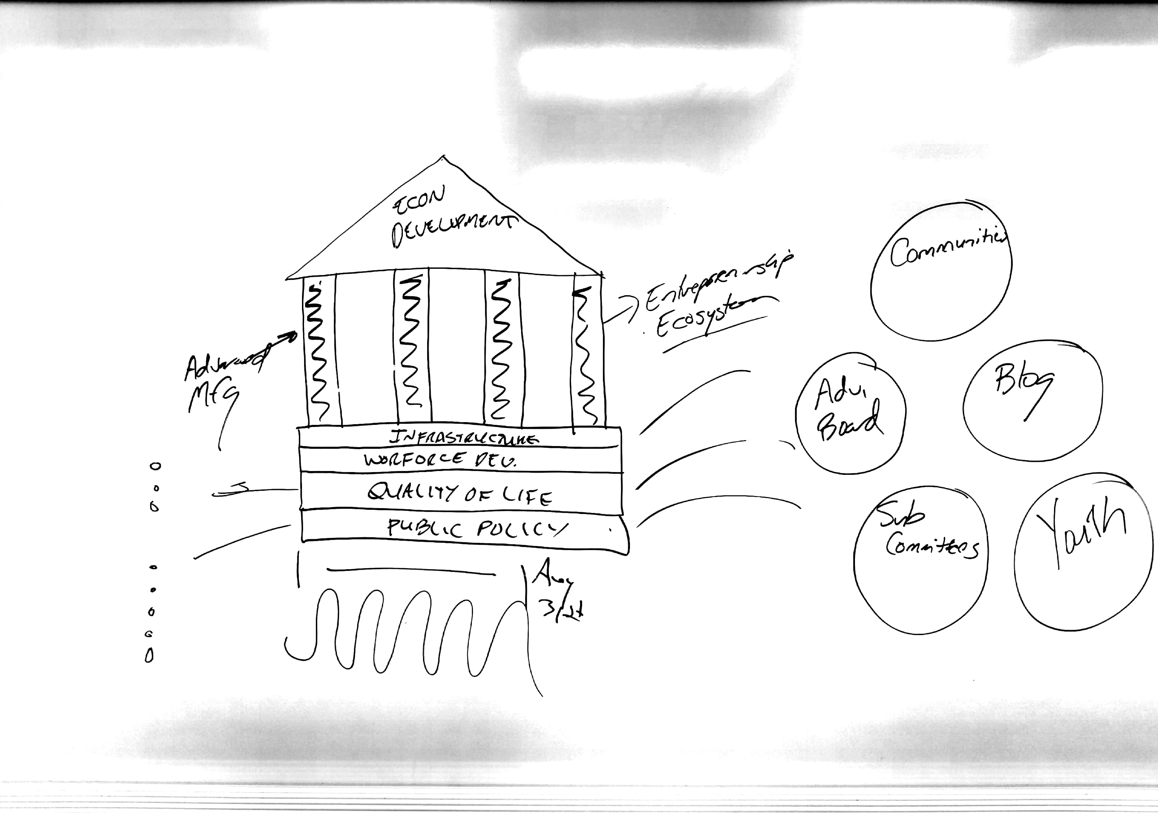

Draft Recommendations for Executive and Legislative Action
Presented by Jerimiah Rieman, Director of Economic Diversification Strategy and Initiatives, Office of the Governor (see Appendix, Potential Recommendations v1)
The ENDOW Executive Council is tasked with identifying recommendations for executive and/or legislative action in its December 2017 report. For each recommendation moved forward, it will be important to discuss the objective, case for action (data), any measures and/or metrics to evaluate impact, budget or other needs (e.g., staffing), and to identify next steps.

Ready for drafting

• Education attainment and delivery
• STEM Innovation fund
• Entrepreneurial ecosystem
• Air service – capacity purchase agreement
• Crypto currency
• Vertical take-off and landing vehicles (flying cars)
• Funding for the establishment of business development and innovation zones
• State technology contracts – WY contractor preference and manageable contracts
• ENDOW statute changes – leadership structure, number of members

May be ready for drafting, but require additional work

• Sector strategies framework
• Require broadband conduit be installed in all new buildings via code or permit
• Create a broadband czar to coordinate deployment of broadband
• Uniform or maximum franchise fee for broadband
• One dig policy for broadband
• Grant program for installation of broadband to underserved communities

Not ready for drafting at this time

• Liquor licensing
• Artificial intelligence regulatory framework
• Business development and innovation zone pilot program
• Examine how the state invests its funds – increased risk tolerance
• Career technical education scholarship fund

Timeline for Recommendations
- Conversation in small groups now; public input and work today and tomorrow; agree on a set of potential recommendations tomorrow.
- November 5 – deadline for Executive Council member to submit potential recommendations that were NOT been approved at this meeting. Any submissions under this timeline must be detailed.
- November 6 – subcommittees and staff will draft potential recommendations approved at this meeting for Executive Council’s initial review and consideration.
- December 11 or 12 – finalize list of recommendations to be included in final report to be submitted at the end of December.

Full Council and Small Group Discussions of Potential Recommendations For Executive and Legislative Action
Broad support of proposed recommendations. Discussion about educational attainment goal via legislation: absolutely should be done, but needs to be aligned to the economic sectors/ industry needs.

Bylaws and Staff Check -In
- Bylaws approved. (see Appendix, Final DRAFT Bylaws). Budget and minutes will be supplied regularly at future meetings. Elections needed for Treasurer and Secretary
- Social Media Policy approved. (see Appendix, Draft_ENDOW Social Media Comments Policy)
- December Required Report timeline (see Appendix, Suggested timeline process and timeline for ENDOW DEC 2017 Report)
November 6: Draft Version 1 out for review
November 13: Revisions due back for Version 2
November 30: Draft Version 2 out for review
December 11/12: ENDOW meeting to finalize report
December 15: Final draft out for review
December 18: Revisions due back for final version
December 20: Final version to Co-Chairs for sign off
December 22: Final report to Governor and Legislature

Staff Presentations
- Sector Strategies (Shawn Reese)
- Business Development and Innovation Zones Concepts (Sarah Fitz-Gerald)

Small Group Discussion on Sector Identification
Broad support for eight sectors:

- energy (value added energy products, including for minerals, trona, bentonite, etc.)
- tourism
- financial services
- advanced/synergistic manufacturing
- value-added agriculture
- health care tech
- information tech
- transportation tech
Additional discussion that any sector approach needs strong connection to business and industry. Streamline!

Conclusions and Recommendations
- Action item for all Council members: feedback on all draft legislative recommendations, (see Appendix): November 5 – deadline for Executive Council members to submit potential recommendations that were NOT approved at this meeting. Any submissions under this timeline must be detailed.
- University of Wyoming at December meeting with a presentation on the agenda
- Youth outreach during the December meeting
- Greg requests presentation on worldwide top economic sectors of the future, followed by discussion of what is needed to really make those sectors happen.
- Next Meeting: December 11 and 12, Laramie

Appendix (with links to documents)
Potential Recommendations v1

Final DRAFT Bylaws

Draft ENDOW Social Media Comments Policy

Suggested timeline process and timeline for ENDOW DEC 2017 Report

Sector Strategies Presentation by Shawn Reese, Wyoming Business Council

Business Development Innovation Strategies Presentation by Sarah Fitz-Gerald, Wyoming Business Council

